9. Metabolic Rates and Energetics of Vertebrates *Ch 48*

______________________________________________________________________________

I. Metabolic Rates of Animals *(1135-1136)*

A. The Meaning of Metabolic Rate

1. The metabolism equation

2. How metabolic rates are measured

3. Resting metabolic rate

4. Relevance to ecology

B. Metabolic Rates and Environmental Temperatures

1. In ectotherms

2. In endotherms

3. Cost of endothermy

C. Effects of Body Size on Metabolic Rate

1. SA:V relationships

2. Total metabolic rate versus mass‑specific metabolic rate

3. Size and metabolic rate

4. Effects on food needs of endotherms

II. Implications for Ecology and Behavior

A. Metabolic Rates and Energy Requirements

B. Ecological and Behavioral Consequences of Thermoregulatory Strategies

1. Food types

2. Hunting styles

3. Home range size and population density

4. Limits on body sizes

5. Times of activity

III. Metabolic Rates During Activity

# A. Resting versus Active Metabolic Rate

B. Aerobic versus Anaerobic Metabolism

1. Biochemical pathways

2. Aerobic capacity

3. Burst activity and anaerobic metabolism

4. Oxygen debt

9-1

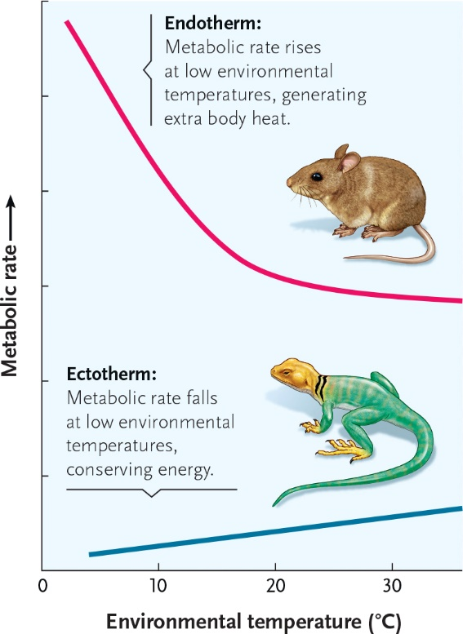

9-2





